**Summary program**

In this experiment, we must be use USB data cable to plug in the RGB LED Circular expansion board interface. As shown in the figure below.

The battery is not enough voltage,it will affect the effect,such as color saturation of RGB lamp is reduced or microphone not work normally.

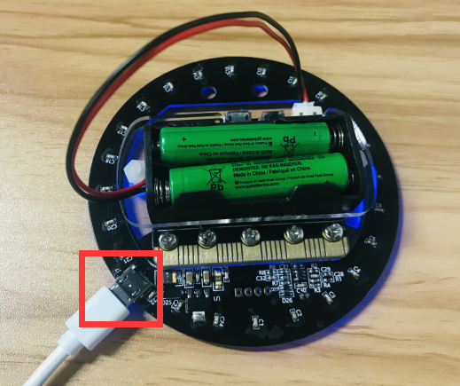

**Experimental phenomena:**

After the program is downloaded, the RGB LED Circular lights up the first light is blue. At this time, press the A key to enter the light mode. Then we need to press the reset button. Next, press the B key to enter the voice cut light mode.

We set the brightness of the light in the program to 100. If you think that the light is too dark or too bright, you can directly modify the brightness of the program. As shown in the figure below.

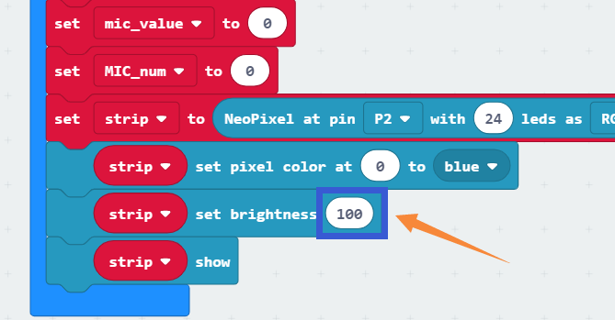

Note: we cannot enter B mode after entering A mode, we need to press the reset button to reselect mode.(A or B)